**Revision:**

**Question 21 (6 marks)**

Swimming is a motor skill that involves a person propelling themself through the water using their arms and legs. Swimming is considered to be a form of general motion.

(a) Define ‘general motion’ and justify how swimming is an example of this type

of motion. (3 marks)

(b) List three muscles of the legs that are used in the skill of swimming. (3 marks)

1.

2.

3.

**Question 22 (9 marks)**

The circulatory system plays a vital role in the delivery of oxygen and nutrients to the working muscles during exercise. Blood is the fluid transported by the circulatory system to assist in performing this function.

(a) Identify **three** other functions of blood. (3 marks)

(b) List the **three** types of blood vessels found in the body and give **one** structural feature of each. (6 marks)

**Question 25 (7 marks)**

Tayla is being taught the skill of throwing a discus. At the completion of the throw her teacher says,

“Extend your legs and keep your body more upright as you release the discus.”

(a) The teacher has provided Tayla with verbal cues to assist in improving her performance. Name the **two** other types of cues that could be used by the teacher to improve Tayla’s performance and give **one** specific example for each. (4 marks)

The teacher is providing cues to encourage Tayla to release the discus with optimal projection to gain the greatest distance. There are three factors relating to the release of the discus that influence its flight path and create optimal projection.

(b) From the teacher’s statement in part a, identify the factor they are attempting to improve in Tayla’s technique. State the other **two** factors that also need to be considered to optimise the distance that the discus travels. (3 marks)

**Question 27 (8 marks)**

During a game of tennis, players are continuously processing information and making decisions in an attempt to out smart their opponent and win a rally.

(a) Complete the diagram below showing the phases of information processing that a player goes through and use tennis to provide an example of each. (6 marks)

**1. Identification of Stimuli**

The player hears the ball being hit and sees the ball coming towards them.

**4. **

**2. **

**3. **

(b) Elite tennis players are able to process information faster than a player who is beginning to learn. With reference to the first phase of information processing, explain why this is the case. (2 mark)

**Question 28 (3 marks)**

When kicking a soccer ball for distance, a player will need to coordinate the linear motion of the kicking leg to create linear velocity in the ball.

(a) Describe **two** factors the soccer player can increase to maximise the amount of linear velocity transferred to the soccer ball. (2 marks)

(b) Give **one** example of how the soccer player can modify their technique to maximise linear velocity. (1 mark)

**Question 29 (15 marks)**

Turia Pitt is an ultra marathon runner who, during an event in the Kimberley region in 2011, was caught in a bushfire and suffered burns to 65 per cent of her body. Prior to the event Turia was competing at an elite level as an ultra-marathon athlete. After this incident she had to learn to walk again and endured months of recovery to return to a basic level of fitness and skill.

(a) Identify and with use of relevant examples, describe the **three** phases of motor learning that Turia would have to go through to return to her elite level. (9 marks)

Vaughan has been practising his basketball jump shots at home to improve his consistency in games. He practises by taking jump shots at varying distances from the ring, starting at one metre. After each successful shot he takes one step back to gradually increase the distance.

(b) Vaughan will need to adjust the way in which he releases the ball as he moves further from the ring in order for the shots to be successful. Describe **two** factors that Vaughan will manipulate in order to ensure he is successful each time he shoots the ball. (6 marks)

**Question 32 (15 marks)**

Natalie Cook is an Australian professional beach volleyball player and Olympic gold medallist. Cook has mastered the ability to play a variety of volleyball shots to move the ball around the playing area, giving her and her teammate the best opportunity to win points.

(a) Cook modifies the trajectory of the volleyball to suit the purpose of the shot she is playing. The trajectory of any projectile, including a volleyball, can be typically categorized in three ways. Name the three typical trajectories of a projectile and give the purpose of each. Provide an example of a situation when Cook would use each trajectory in a game of beach volleyball. (9 marks)

**Question 22 (8 marks)**

The image below shows a gymnast performing a backflip on the ‘Beam’. ‘Beam’ is an artistic gymnastic event involving the performance of a routine on a thin beam, which is typically raised from the floor on a stand.

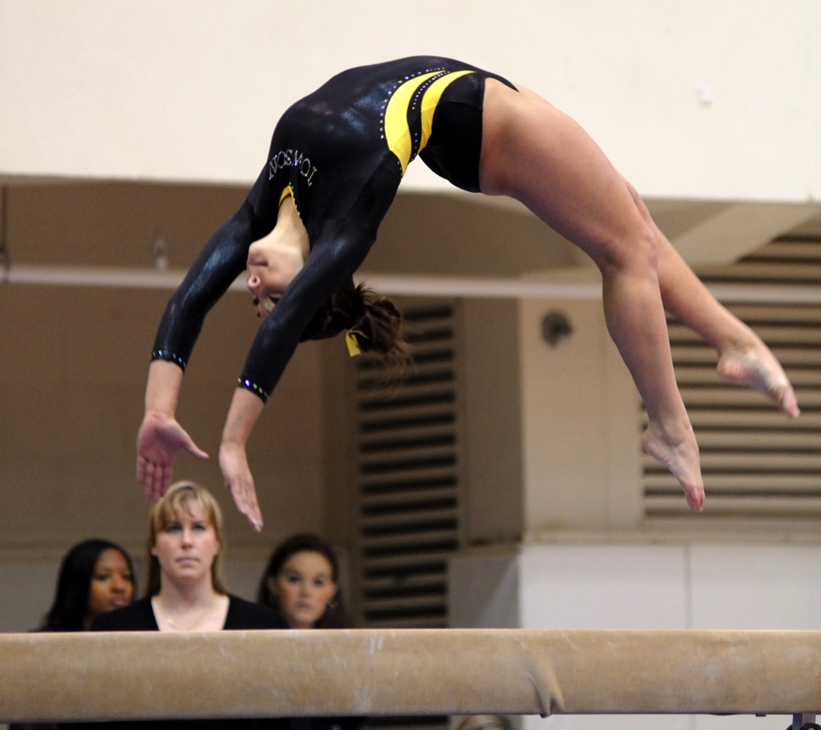

(a) Identify the types of movement occurring at the gymnast’s: (3 marks)

Ankles:

Hips:

Spine:

**Question 24 (4 marks)**

Using the Fosbury Flop method, an elite high jumper is able to clear a bar set at 2.40 metres high. The height that can be cleared by a high jump athlete is limited due to the force required to lift the athlete’s centre of gravity.

(a) Identify, with a (X) on the image below, the point that represents the high jumper’s centre of gravity as he clears the bar. (1 mark)

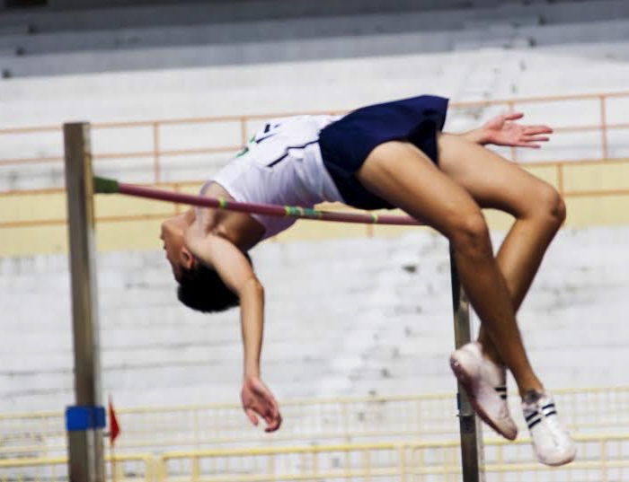

(b) Movement can be classified as either simultaneous or sequential. The appropriate application of movement depends on the aim of the activity. Identify and explain the appropriate movement used in high jump. (3 marks)

**Question 25 (7 marks)**

The Department of Education provides swimming classes for primary school children to help decrease the incidence of drowning. The image below shows children taking part in a typical lesson. The children are sitting on the edge of the pool practising their freestyle kick whilst listening to feedback from the swimming instructor.



(a) Identify and describe the type of feedback being used in this situation. (3 marks)

(b) The instructor reminds one of the children, “Keep your legs straight and point your toes”. Identify the purpose of this type of feedback. (1 mark)

(c) According to Fitts and Posner’s model of motor learning, identify which stage of learning these children would most likely fit into. Describe **two** characteristics of learners in this stage. (3 marks)

**Question 26 (3 marks)**

The graph below shows the effect that exercise has on the percentage distribution of blood to different systems of the body.

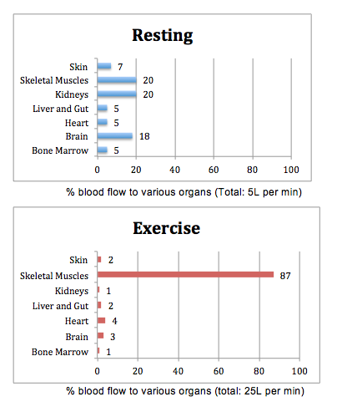

Explain the change in the distribution of blood during exercise and discuss what happens during exercise to allow the body to direct blood to different areas. (3 marks)

**Question 29 (15 marks)**

The image below shows the movements of a tennis player as they perform an overhead serve. The aim of service is to deliver the ball, cross-court, into the opponent’s service box. The faster the ball travels, the less time the opponent has to react to the flight path of the ball.

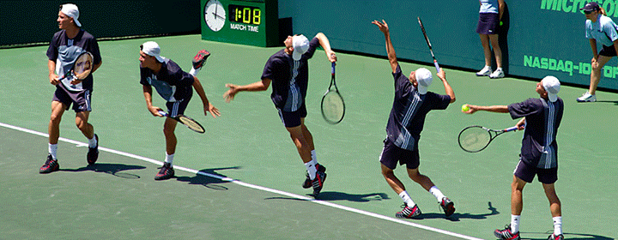

(a) With reference to ‘base of support’ and ‘centre of gravity’ explain how the player moves to manipulate his balance and stability and create a successful serve. (7 marks)

**Question 30 (15 marks)**

The ‘Tour De France’ is one of the world’s most famous cycling events. It takes place annually in France and consists of 21 day-long segments (stages) covering approximately 3500 kilometres.

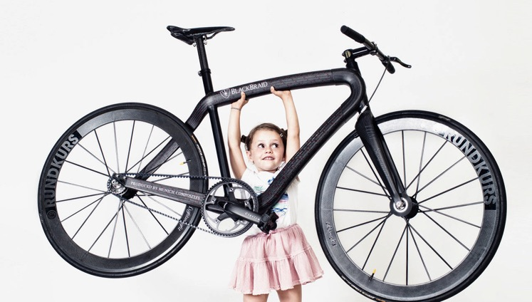

(a) Riders of the ‘Tour de France’ use bicycles made of carbon fibre as they are extremely lightweight compared to an aluminium frame. With reference to one of Newton’s Laws, explain why cyclists will benefit from using a bicycle that has a very light frame. (6 marks)

**Question 30 (15 marks)**

The ‘Tour De France’ is one of the world’s most famous cycling events. It takes place annually in France and consists of 21 day-long segments (stages) covering approximately 3500 kilometres.



(a) Riders of the ‘Tour de France’ use bicycles made of carbon fibre as they are extremely lightweight compared to an aluminium frame. With reference to one of Newton’s Laws, explain why cyclists will benefit from using a bicycle that has a very light frame. (6 marks)

_______________________________________